**Surveillance task – replication protocol**

**General:**

**The experiment will consist of four parts:**

EC procedure -> filler tasks -> evaluation measure -> memory questions

**Two between-participants conditions:**

CS-US assignment: CS1-pos/CS2-neg, CS2-pos/CS1-neg

**Procedure:**

1. **Evaluative conditioning procedure**

**Task structure:**

**General**

* 5 blocks with 86 trials each
* Each trial takes 1.5 seconds with no inter-trial interval
* Of the 86 trials, 8 are CS-US pairs and 78 are target/filler trials.
* Each trial can consist of one image, one word, two stimuli (both images, both words, or one of each), or a blank screen.
* In target trials, CS-US pairing trials, and in some fillers trials, every stimulus is presented on either the left or right side of the screen.
* Eleven filler trials (involving single items) appear in varying locations (e.g., top right of the screen)

Participants need to press the spacebar every time they see the target

* Responses to all trials should are recoded.

**Conditioning trials**

* Each CS-US pair is preceded and followed by a blank trial, and these ‘triplets’ are fixed at various positions throughout the procedure (10-12, 20-22, 30-32, 40-42, 50-52, 60-62, 70-72, 80-82, with an alternation between the CSpos and CSneg).
* The assignment of CS-US pairs to the fixed positions **is random**, with the restriction that CSpos and CSneg are presented alternately.
* Conditioning trials **in each block**: 4 CS1-Positive USs, and 4 CS2-Negative USs.
* Each specific US appears only once (total of 10 words and 10 images from each valence).
* The CS and the US are presented close to each other (approximately a 1 cm space between the two stimuli).
* The CS is always larger than the US
* All these slides are fixed (see materials folder)

**Target trials**

* Among 78 filler trials, 10 display a target.
* The target is different in each block and the order of the five targets is random for every participant.
* The target appears 5 times alone (3 time as an image + name, and 2 times just name), two times with a neutral image (one time an image + name and one time just the name), and three times with a neutral word (2 time as image + name, and 1times just name; different images/words in each block).
* these slides are fixed (see materials folder)

**Filler trials**

* 68 trials do not include a target. Among these 68, 30 are blank screens
* 16 blank screens are in fixed positions (before and after the pairing, see above)
* The location of the target and filler trials is randomized in the remaining positions.
* The remaining 38 filler trials in each block are the same and include:
* Two images that are similar to the CSs/targets. Each appears: once alone (not centered), twice with a neutral word (two identical trials but in a different location to the stimuli), and twice with a neutral picture (two identical trials but in a different location to the stimuli. This leads to a total of 10 trials.
* 6 neutral words, two appears 2 times, and 4 appear once. This leads to a total of 8 trials (2 of them are centered and 6 are not)
* 4 neutral images, one appear twice, three appears once: a total of 5 trials (2 centered and 3 are not).
* 6 image-image trials (3 different pairs that are made from the 4 neutral pictures above; one pair appear three times, one pair appear twice, and one pair appears once.
* 3 word-word trials (2 different pairs, one appear twice, one appear once)
* 6 image-word trials (3 different pairs that are made from the above neutral pictures and words. Each of them appear twice.
* All these slides are fixed (see materials folder)

**Stimuli**

CSs and Targets are Pokémon were pretested on Prolific Academic (see pre-test summary) for valence and familiarity. We chose 9 stimuli that were rated neutrally and as not familiar. We tested for no difference in valence and familiarity between the two CSs.

If a lab has the time and the resources, it can run a pretest with 20 Pokémon (20 that were rated around the neutral point in our pretest; see the pretest-prolific summary, and pretest2 file) using participants similar to the ones who will complete the replication task.

If no time/resources for pretesting are available, then the lab will use the stimuli that were pretested by us:

**CSs**

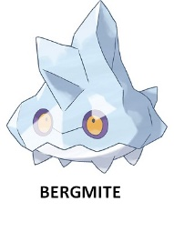 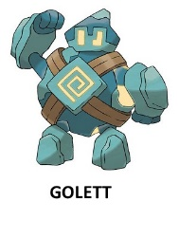

**Targets:**

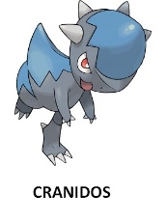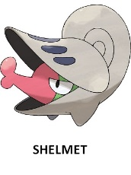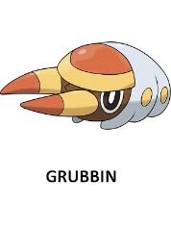 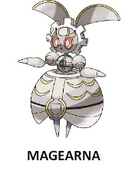 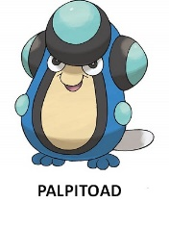

**Pokémon fillers:**

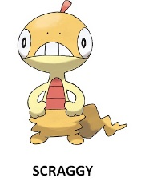 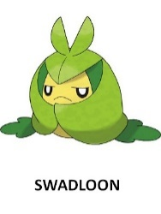

**USs**

Most of the USs (all the words, 9 positive pictures and 8 negative pictures) are identical to the USs used in Jones, et al. (2009), Experiment 5. The three pictures which we were not able to find were replaced with IAPS pictures

**Positive USs:**

**Words:** Useful, Calming, Desirable, Appealing, Worthwhile, Relaxing, Beneficial, Valuable, Terrific, Commendable

**Images:**

From Jones et al., (2009):

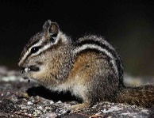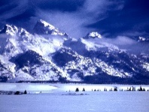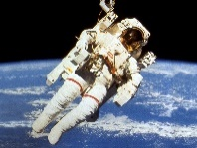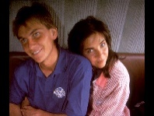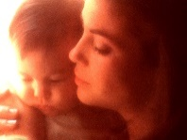

An additional picture:

****(5780): Valence: 7.52 (1.45), Arousal: 3.75 (2.54)

**Negative USs:**

**Words:** Inferior, Harmful, Offensive, Troublesome, Upsetting, Terrifying, Unhealthy, Useless, Dislikable, Undesirable

**Images:**

From Jones et al., (2009):

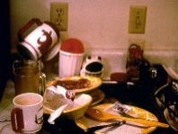 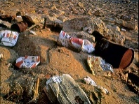 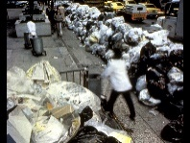 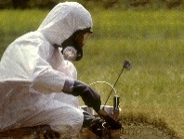 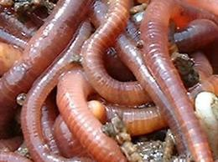 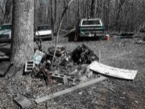  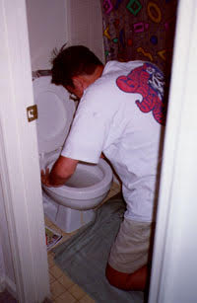

Additional picture:

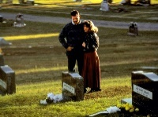 (9220) Valence: 2.06 (1.54), Arousal: 4.00 (2.09)

**Neutral stimuli:**

6 neutral words: Book, Concrete, Umbrella, Pencils, Glasses, Computer

4 neutral images (from the IAPS)

(7020) 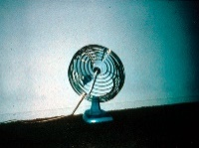 (7035) 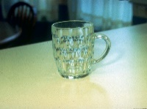 (7185) 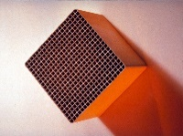 (7050) 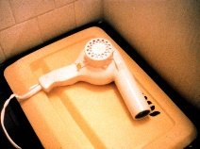

|  |  |  |  |  |
| --- | --- | --- | --- | --- |
| Image | pleasure | SD | arousal | SD |
| 7020 | 4.97 | 1.04 | 2.17 | 1.71 |
| 7035 | 4.98 | .96 | 2.66 | 1.82 |
| 7185 | 4.97 | .87 | 2.64 | 2.04 |
| 7050 | 4.93 | .81 | 2.75 | 1.80 |

**Instructions**

At the beginning:

**First slide:**

*Imagine that you are a security guard watching for deviant activity at a business. Your job requires that you pay attention at all times, and respond quickly when something suspicious happens.*

*In our lab we study attention and rapid responding, and in this experiment you’ll be asked to play the role of the security guard.*

*Specifically, you will be attending to a number of items presented on the computer screen, and you’ll be responding as quickly as possible when a target item appears by pressing the spacebar.*

*Press the spacebar to continue*

**Second slide:**

*The target item will appear at random several times throughout the experiment. The target item may appear as an image or as a name. So be sure to pay attention at all times and focus on the screen, because you never know when the target item will appear.*

*A number of filler items that we’ve selected from our stimulus pool will also be shown randomly to make the task more challenging. These distractors are both pictures and words that were just randomly picked from our collection.*

*Sometimes two images will appear on the screen at the same time, and sometimes only one image will appear. Be sure to hit the spacebar only when the target appears.*

*The target might appear anywhere on the screen as well, and it might also appear with other images. So whenever you see a target image or name anywhere on the screen, hit the spacebar.*

**Third slide:**

*The items will be displayed rapidly, so make sure that when you see a target, you hit the spacebar before it disappears.*

*Again, be sure to pay close attention throughout the experiment so that you can respond as quickly and accurately as possible.*

*There will be five separate surveillance tasks of about 4 minutes each.*

*Each task will have a different target, and all of the target items will be cartoon creatures.*

**Instructions for each target:**

*For this task, the target creature is XXXXXX:*

*[TARGET PICTURE]*

*So, whenever XXXXX (his name or his picture) appears on the screen, hit the spacebar as quickly as possible. Hit the spacebar whenever you see an image of XXXXX or the word XXXXX.*

*Press the spacebar to start the this task*

1. **filler tasks**

participants will complete two questionnaires in a fixed order

1. **Need for cognition** (18-item NFC Scale; [Cacioppo, Petty, & Kao, 1984](https://www.sciencedirect.com/science/article/pii/S0022103116303419#bb0030))

*For each of the following statements please indicate to what extent they apply to you.*

*Please note that there are no right or wrong answers*.

1. I would prefer complex to simple problems
2. I like to have the responsibility of handling a situation that requires a lot of thinking
3. Thinking is not my idea of fun
4. I would rather do something that requires little thought than something that is sure to challenge my thinking abilities
5. I try to anticipate and avoid situations where there is likely chance that I will have to think in depth about something
6. I find satisfaction in deliberating hard and for long hours
7. I only think as hard as I have to
8. I prefer to think about small, daily projects to long-term ones
9. I like tasks that require little thought once I’ve learned them
10. The idea of relying on thought to make my way to the top appeals to me
11. I really enjoy a task that involves coming up with new solutions to problems
12. Learning new ways to think doesn’t excite me very much
13. I prefer my life to be filled with puzzles that I must solve
14. The notion of thinking abstractly is appealing to me
15. I would prefer a task that is intellectual, difficult and important to one that is somewhat important but does not require much thought
16. I feel relief rather than satisfaction after completing a task that required a lot of mental effort
17. It’s enough for me that something gets the job done; I don’t care how or why it works
18. I usually end up deliberating issues even when they do not affect me personally

Scale = ("strong agreement", "moderate agreement", "slight agreement", "neither agreement nor disagreement", "slight disagreement", "moderate disagreement", "strong disagreement")

1. **Need to evaluate**  (16-iten NFE scale; Jarvis & Petty, 1996)

*For each of the following statements please indicate to what extent they are characteristic of you.*

*Please note that there are no right or wrong answers.*

1. I form opinions about everything
2. I prefer to avoid taking extreme positions
3. It is very important to me to hold strong opinions
4. I want to know exactly what is good and bad about everything
5. I often prefer to remain neutral about complex issues
6. If something does not affect me, I do not usually determine if it is good or bad
7. I enjoy strongly liking and disliking new things
8. There are many things for which I do not have a preference
9. It bothers me to remain neutral
10. I like to have strong opinions even when I am not personally involved
11. I have many more opinions than the average person
12. I would rather have a strong opinion than no opinion at all
13. I pay a lot of attention to whether things are good or bad
14. I only form strong opinions when I have to
15. I like to decide that new things are really good or bad
16. I am pretty much indifferent to many important issues

Scale = ("extremely characteristic", "slightly characteristic", "neither characteristic nor uncharacteristic", "slightly uncharacteristic", "extremely uncharacteristic")

* Participating labs should use a translated version of the above questionnaires where available. If such a translation is not available, then they can translate the questionnaires themselves (note: we will not actually use the responses for these questionnaires in our study).

1. **Evaluation task**

We use the forced choice task (Jones, Fazio, & Olson, 2009; Kendrick & Olson, 2012)

* The task include 30 trials.
* On each trial, a pair of stimuli appear on the screen and participants are asked to indicate which image they prefer.
* 10 of the trials present the CSs (2 present CSpos and CSneg, 4 present CSpos with one of the neutral targets/fillers, and 4 present CSneg with one of the neutral targets/fillers, see the slides folder for specific pairs)
* The remaining 20 trials will consist of filler trials, each presenting two neutral targets/fillers (see slides folder)
* Two filler trials always precede the first critical trial, and subsequent critical trials appear at fixed points separated by filler trials (positions 3, 6, 9, 12, 15, 18, 21, 24, 27 and 30).
* The 10 critical trials will be randomly assigned to the fixed positions

**Instructions for this task:**

*Next, you’ll be presented with 30 pairs of target and filler creatures from the surveillance tasks, and we’d like you to indicate which one you like better. You don’t need a reason for liking one rather than the other, just give us your gut feelings.*

*We are interested in knowing if the pleasantness or unpleasantness of these stimuli affects the ability to attend and rapidly respond to them, so we need you to indicate which you prefer.*

*Remember, you don’t need a reason for liking one rather than the other, so just go with your gut. Please respond quickly.*

1. **Awareness test**

Seven questions, presented in a fixed order:

1. *Think back to the very first part of the experiment. Did you notice anything out of the ordinary in the way the words and pictures were presented during the surveillance tasks?*

Response: open-ended

*Did you notice anything systematic about how particular words and images appeared together during the surveillance tasks?*

Response: open-ended

*Did you notice anything about the words and images that appeared with certain cartoon creatures?*

Response: open-ended

1. For some participants, during the first task, there was one cartoon creature that always appeared with positive images and words, and one that always appeared with negative images and words. Do you think it happened in your case?

Response options:

* No, I did not notice if that happened in my task
* Yes, that happened in my task.

The next two questions in a random order:

1. During the first task, which of the two characters was consistently presented with positive images and words? [presenting the images of the two CSs]

Response options:

BERGMITE (certainly), BERGMITE (probably), BERGMITE (guess), GOLETT(guess), GOLETT (probably), GOLETT (certainly).

1. During the first task, which of the two characters was consistently presented with negative images and words? [presenting the images of the two CSs]

Response options:

BERGMITE (certainly), BERGMITE (probably), BERGMITE (guess), GOLETT (guess), GOLETT (probably), GOLETT (certainly).

* We will use these two questions to test if EC effects are related to memory about the pairings.

1. *How familiar were you with the cartoon creatures that appeared in the surveillance tasks?*

Scale: 0 = Not Familiar at all, 8 = Very Familiar

* We will use this item as a covariate in our analyses

**Coding of aware participants:**

We will calculate three awareness scores:

1. Following Olson & Fazio procedure:

* Two independent raters will code participants’ free responses to questions 1-2 and judge whether they were correctly aware of systematic CS-US pairings.
* Participants will be judged to be contingency-aware if both raters agreed that they expressed awareness of the pairings in response to at least one of the questions.

1. Following Bar-Anan, De-Houwer & Nosek (2010) procedure:

* Participants will be coded as aware if they chose the “yes” answer in question 4.

1. Modifying Bar-Anan, De-Houwer & Nosek (2010) procedure:

* Participants will be coded as aware if they chose the “yes” answer in question 4 + correctly identified the valence with which each of the two CSs appeared during the task (questions 5-6).

**Exclusions of participants:**

1. Performance in the surveillance task: we will exclude participants with more than three standard deviations beyond the mean error number in the surveillance task (error = responding to non-target trials, or not responding to target trials).
2. Three sets of analyses will be carried out:
3. One including all participants
4. One excluding aware participants using the Olson & Fazio procedure
5. One excluding aware participants using Bar-Anan, De-Houwer & Nosek (2010) procedure.